Project Design Phase-II
Technology Stack (Architecture & Stack)

Date | 27-06-2025
Team ID | LTVIP2025TMID20382
Project Name | booknest: where stories nestle
Maximum Marks

Technical Architecture:
The Deliverable shall include the architectural diagram as below and the information as per the table1 & table 2
Guidelines:
Include all the processes (As an application logic / Technology Block)
Provide infrastructural demarcation (Local / Cloud)
Indicate external interfaces (third party API’s etc.)
Indicate Data Storage components / services
Indicate interface to machine learning models (if applicable)
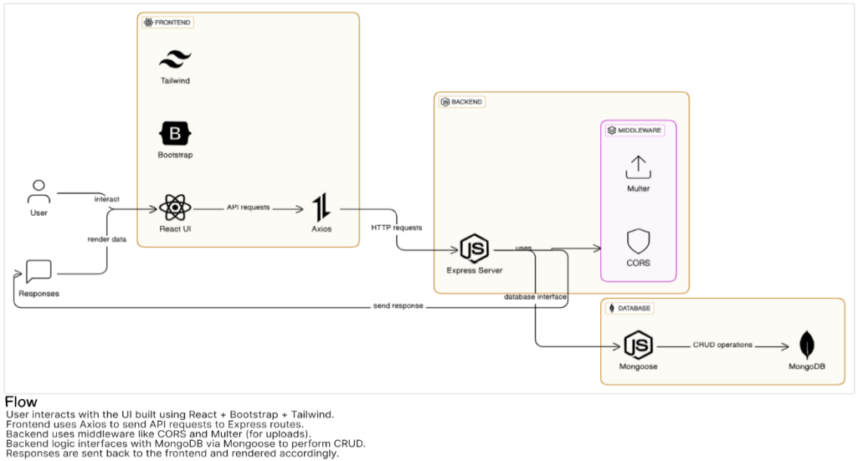

Table-1 : Components & Technologies:
S.No | Component | Description | Technology
 | User Interface | User interaction via Web UI (Desktop/Mobile) | HTML, CSS, JavaScript ,React Js
 | Application Logic-1 | Backend server logic – API handling, authentication, order processing | Node.js, Express.js
 | Application Logic-2 | Email service integration
 | Application Logic-3 | Payment integration logic
 | Database | Stores user data, books, orders, inventory | MongoDB (NoSQL)
 | Cloud Database | Cloud-hosted database | MongoDB Atlas (Cloud Database)
 | File Storage | Book images, profile pictures, and document | AWS S3
 | External API-1 | Payment Gateway API integration
 | External API-2 | Authentication via social platforms
 | Machine Learning Model | NA
 | Infrastructure (Server / Cloud) | Application Deployment on Local System / Cloud | Node.js Server + MongoDB local

Table-2: Application Characteristics:
S.No | Characteristics | Description | Technology
 | Open-Source Frameworks | Frontend & Backend frameworks | React.js, Node.js, Express.js, MongoDB (MERN Stack)
 | Security Implementations | Authentication, Authorization, and Data Security | JWT (JSON Web Tokens), OAuth 2.0, HTTPS
 | Scalable Architecture | Microservices-friendly REST API, Scalable NoSQL DB, Cloud-based deployment | MERN Architecture with Cloud Database (MongoDB Atlas), REST APIs, Load Balancing
 | Availability | High availability with cloud hosting | Cloud services (AWS, Vercel, Railway, MongoDB Atlas), CDN (Cloudflare), Load Balancers
 | Performance | optimized database queries, asynchronous APIs, | MongoDB indexing, Asynchronous Node.js

